**12U ENCLOSURE 19" CABINET 600X800 | 12U 800MM DEEP CABINET FLOOR STANDING**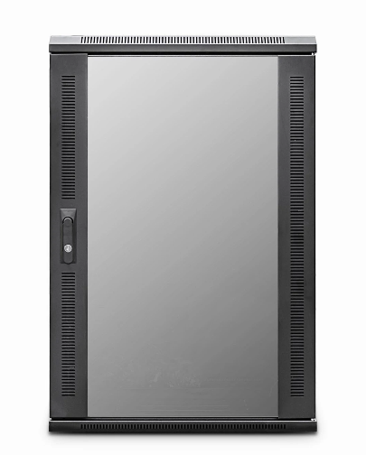

**CAB-FE-12U-68**

**DESCRIPTION**

Small-Scale, Quality Networking Deployment - Competitively Priced

Looking to deploy a small-height data or telco cabinet but need the

advantages of a fullheight cabinet but don’t need a fitted fan tray?

The newly designed ValuCab 12U 800mm Deep Cabinet and 15U floor-standing cabinets are ideal for

many installations that need all the advantages for full width, 19-inch racking,

full depth, adjustable mount posts but does not include a fitted fan tray, thus keeping

your costs to a minimum. Of course our other accessories including castors, jacking

feet and M6 cage nuts and bolts.

With more networking, telco, PBX and broadcast equipment becoming more

compact and of course thinking all installations do not require a high,

towering 42U cabinet for example, the new ValuCab 12U 800mm Deep Cabinet and 15U range are

ideal for IT rooms, PBX switching centres, SME business applications, but without the

extra height clearance needed.

Superb-build quality of course is assured, multiple cable entries, together

with left/right hinged safety-glass door as standard, together with a hard-wearing

black, powder-coated finish and assembled here in the UK..

**SPECIFICATIONS**

* 12U high 600W 800D
* ETSI 19” front/rear profiles, adjustable
* Lockable vented glass door, reversible
* Removable side panels, rear lockable door
* Ideal for SME, IT Rooms, PBX & Broadcast
* Fitted castors and jacking feet (4))
* UK Assembled and quality assured
* Dimensions:  600(width) x800(depth) x720mm (height)